**Django-ERP User Manual**

**Procurement Management**

## A purchase order

### 1.1 Business Introduction

Purchase orders are used to record the production activities of purchasing materials or services between an enterprise and its suppliers, and to perform warehousing and payment operations based on the purchase orders.

### 1.2 Interface Description

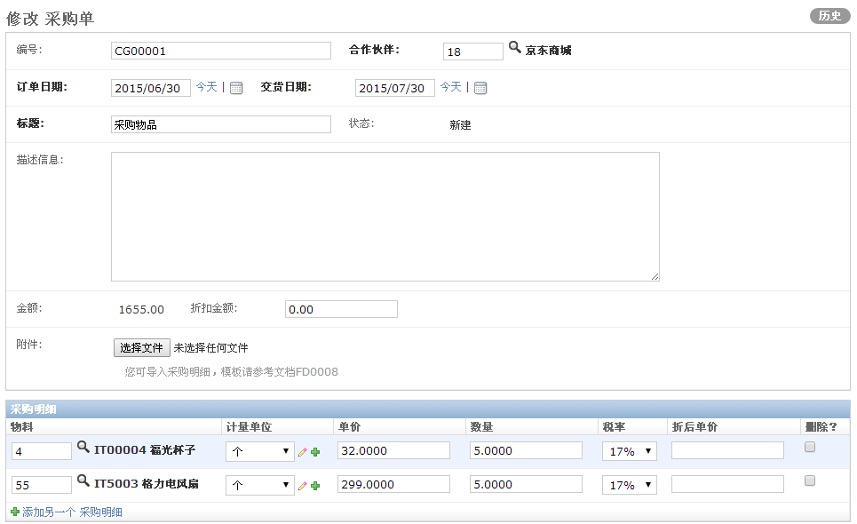

* **Purchase master document**

[Number]: Automatically generated, incremented by serial number, used for retrieval

【Partner】: Please select the material or service provider

【Order Date】: Default is the current date

【Delivery Date】: Default is current date plus 30 days

【 Title 】: Please enter a brief description of this purchase

[Status]: The default is New, which is automatically updated according to different process nodes

【Description】: Please enter a detailed description of the purchase order

【Amount】: Automatically calculated based on purchase details

[Discount Amount]: The discount amount on the total amount. The actual payment amount = amount - discount amount. The discount amount is allocated to each material in proportion, and the depreciation unit price in the detailed material is automatically calculated.

[Attachment]: If there are many purchase details, you can import the details according to the template

* **Purchase details document**

【Material】: Select a material from the material library

【Unit of measurement】: Select the unit of measurement for the material

【Unit Price】: Enter the unit price of this purchase

【Quantity】: Enter the purchase quantity

【Tax rate】: Select the tax rate

[Discounted unit price]: Automatically calculated discounted unit price

### 1.3 Operation Instructions

* **Step 1: Fill out the form**

According to the prompts on the interface, enter the required data and click the [Save] button to save the data.

* **Step 2: Submit documents**

If the purchase order is configured with an approval process, you can click the [Submit] button to enter the approval process;

## 2. Purchase payment

### 2.1 Business Introduction

Record each payment made against the purchase order for reconciliation and verification.

### 2.2 Interface Description

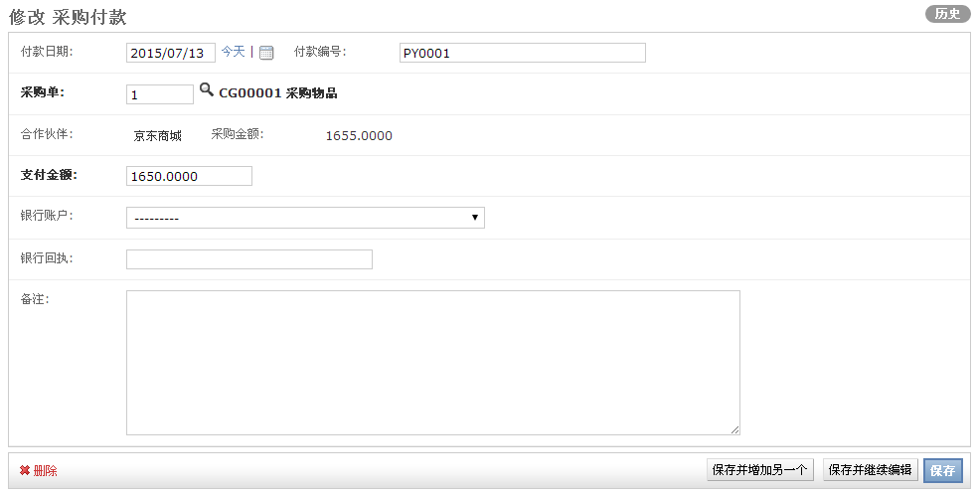

【Payment Date】: Payment date, default is current date

【Payment Number】: Automatically generated, for retrieval

[Purchase Order]: Please select the purchase order corresponding to this payment

[Partner]: Information automatically brought out from the purchase order

[Purchase Amount]: Information automatically brought out from the purchase order

[Payment amount]: The actual payment amount. One payment order supports multiple payments.

【Bank Account】: Select the bank account corresponding to this payment

【Bank Receipt】: Fill in the receipt serial number of this payment

【Remarks】: optional remarks

### 2.3 Operation Instructions

* **Step 1: Fill out the form**

According to the prompts on the interface, enter the required data and click the [Save] button to save the data.

* **Step 2: Submit documents**

If the payment order is configured with an approval process, you can click the [Submit] button to enter the approval process;

## Three invoices

### 3.1 Business Introduction

Record and upload every invoice received by the company for later verification.

### 3.2 Interface Description

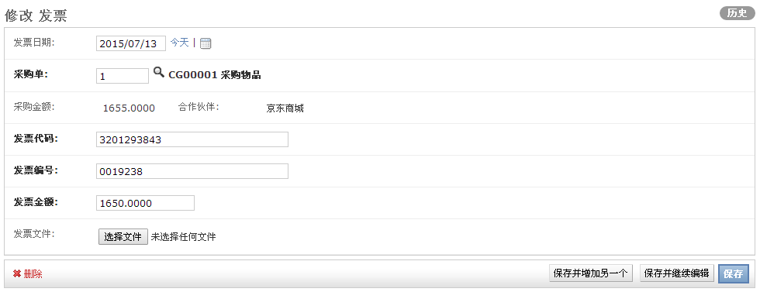

[Invoice Date]: Default is the current date

[Purchase Order]: Select the purchase order corresponding to this invoice

[Purchase Amount]: Automatically brought out from the purchase document

[Partner]: Automatically brought out from the purchase document

【Invoice Code】: Please enter the invoice code

【Invoice Number】: Please enter the invoice number

【Invoice amount】: Please enter the invoice amount

【Invoice file】: Please upload a scanned copy of the invoice

### 3.3 Operation Instructions

* **Step 1: Fill out the form**

According to the prompts on the interface, enter the required data and click the [Save] button to save the data.

* **Step 2: Submit documents**

If the invoice is configured with an approval process, you can click the [Submit] button to enter the approval process;